# Convert smiles files to mol2 and minimize

This can be achieved using either of the listed methods.

1. Singly with Chem3D (Windows)
   1. Download ChemOffice
   2. When you are done, in your start menu, type “Chem3D”, open the program
   3. Drag your smiles file into the program
   4. Click the button labelled MM2 to do energy minimization, wait for the process to complete

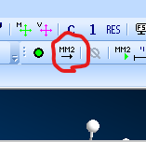

* 1. Click file, then save as, a dialog box appears, in the dropdown below, select SYBYL2(*.mol2)
  2. Save to a directory of your choice

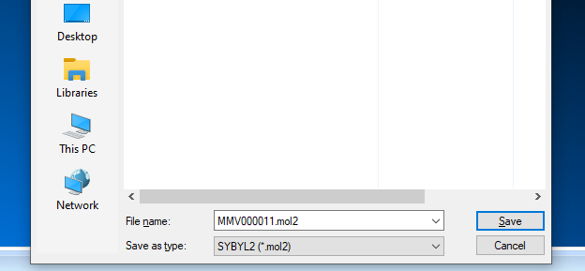

* 1. Repeat for all the files you want to minimize and convert

1. Batch method (OpenBabel: Linux and Windows)
   1. Place all your smiles files in a directory
   2. Open the terminal
      1. On linux: alt + t
      2. On windows, win + R, in the dialog box that appears, type cmd and hit enter
   3. Using the terminal navigate into the directory where your smiles files are
   4. Type the command obabel *.smi -omol2 -m --gen3d and wait for it to finish, watch for error outputs. The mol2 format of each corresponding smiles files are generated in the same directory
   5. Use this command obminimize -o mol2 <filename> > <outputfilename> to minimize each of your generated mol2 files after conversion has completed.

Example: obminimize -o mol2 nifedipin.mol2 > nifedipin.min.mol2

Done!